No solution at X = 0

At X = 1/X Then Y = X liner relation

The ratio between (X-3) and (X)

The inverse domain for this ratio will have no discontinuity.

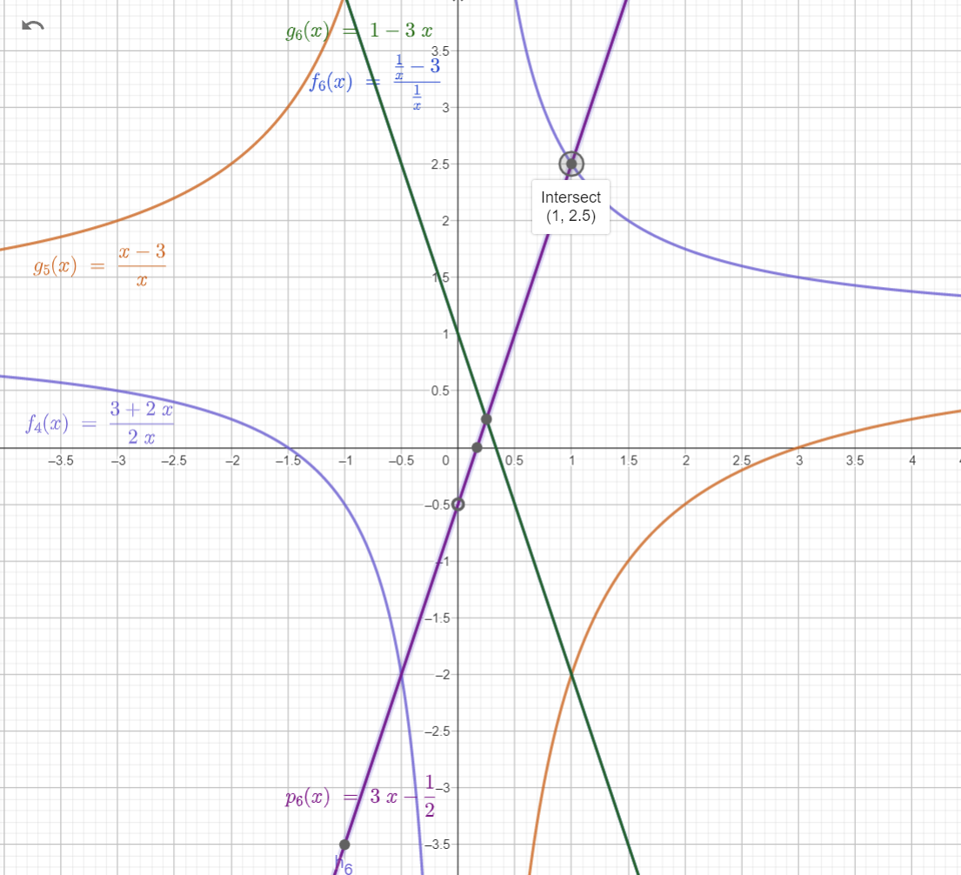

|  |  |
| --- | --- |
| A = 3 and B =1/2 | |
|  |  |
|  |  |
|  |  |
|  |  |
|  |  |
|  |  |

At A = 1 and B =1

A = 2 and B =1

A = 2 and B =1

Subtracting [-1] give us the definition of an odd natural numbers and they will have root at 0.5 for any X

At A = 3 and B =1

$$\left(\frac{3-\frac{1}{X}}{\frac{1}{X}}+1\right)=3*X$$

$$at A=3 and B=12 will have root at \frac{1}{3*12}=\frac{1}{36} \\ \left(\frac{3-\frac{1}{X}}{\frac{1}{X}}+1\right)-\frac{1}{12}=3*X-\frac{1}{12}$$

*We are going to use A =3 and B =2 have root at [1/ (2*3)] = 1/6*

The negative image for this equality

